**[23] Design DFA Which Accepts String Ends With ‘AB’**

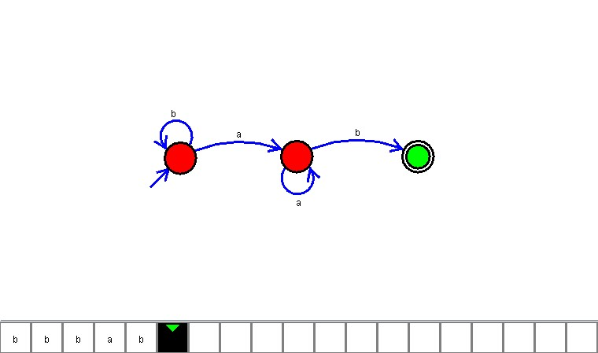

**Result**

The DFA is designed to compute the strings as input using Automaton Simulator